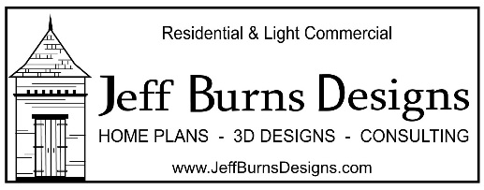
Jeff Burns Designs Custom Project Questionnaire
Please answer the following questions so Jeff Burns Designs can help make your project come to life.
General Information:
First Name:
Last Name:
Email:
Phone #:
Project Description (Home, Renovation, Commercial, Etc.):
Project Location (City, State):
Subdivision & Lot # (If Applicable):
Do You Have A Plat or Land Survey?:
Number of Bedrooms:
Number of Bathrooms:
Number of Powder Rooms:
Specify Room Sizes if possible:
Number of Stories:
Desired Heated Square Footage:
Desired Total Square Footage Under Roof:
Desired Ceiling Heights:
Budget Range:

Additional Information About Your Project:
1. Are there any architectural style(s) that are you are looking to incorporate into your design? Acadian, Colonial, Farm House, Craftsman, Modern, Etc.
2. Are there any specific features you would like to incorporate into your design? (Fireplace(s), vaulted ceilings, wood beams, cook porch, sunroom, etc.)
3. Is there any specific flooring you would like to incorporate into your design? (Hard wood, laminate, Stained Concrete, Ceramic Tile, Natural Stone, wall-to-wall carpet, etc.)
4. Are there any rooms you would like serve a particular purpose? (Game room, office, theatre, in-house gym etc.)
5. Are there any rooms you would like to be located in a specific location? (Ex. I would like my office tucked away into a quiet, private section of the home.)
6. Are there any specific colors you would incorporated into your design? Shutter color, Window Color, Cabinet color, Roof Color, Brick Color, etc.
7. Are there any natural features on your property you would like to be incorporated into your design such as specific views from certain rooms.
8. Are there any natural features on your property you would like to be excluded from views within your design?
9. Are there any outbuildings you would like incorporated into your design? (Guest house, pool house, shed, barn, Shop, etc.)
10. Are there any outdoor features you would like to be incorporated into your design? (Swimming pool, play area, sports court, etc.)
11. Are there any transitional spaces you would like incorporated into your design? (Covered walkway, patio, deck, etc.)
12. Is there a specific quality of natural light you would like to achieve in specific rooms?
13. Do you own any specific furniture that would need to be incorporated into your design?
14. Do you own any equipment that would need to be incorporated into your design?
15. Are higher ceilings in specific rooms important to you? (Above you informed us of the general ceiling height throughout the design.)
16. Are you aware of specific restraints regarding zoning, neighborhood requirements, Architectural Review, or anything else that may be an obstacle when building?
17. Are there any timeline constraints associated with your project completion?
18. Do you have a clear idea of your building budget? (It is recommended to meet with a contractor(s) prior to starting the design process to ensure you are aware of the building costs associated with the size and location of your home.)
19. Have you built or renovated a house before and are familiar with the process?
20. Do you have any further questions? If so, feel free to include them here so we can get them answered for you.
21. If you have any images, sketches, example floor plans, drawings etc., feel free to attach them to this response email and try to include a description if possible.
22. We offer a wide range of 3D services that can be added to your plan process. Which would you get interested in?
- We can provide basic and simple 3D models of your project plans.
- We can provide mid-range 3D services that include color 3D models and rendering using a Natural Color Palette with fly around model videos to help you better visualize your project throughout the design process.
- We can incorporate a more specific material and color palette into your design.
- We can provide room by room 360-degree views.
- We can provide realistic photo model renders of your completed design.

